Introducing RevyPro: Unleash the power of Revysol

RevyPro® is an innovative new fungicide from BASF, joining Revystar® XE as an additional Revysol® containing option in 2025. RevyPro® builds on the proven strength of Revysol® to give excellent efficacy, long lasting protection and outstanding flexibility across crops such as wheat and barley.
RevyPro® formulation
RevyPro® contains 50 g/l Revysol® and 100 g/l prothioconazole and is approved for use on all cereals except oats and offers growers flexibility with application timing, dose rate and mix partners when building their fungicide programmes.
Its unique formulation results in benefits which are greater than the sum of the performance of its active ingredients.
Rebecca Joynt, Senior Plant Pathologist, ADAS said, “RevyPro has good broad spectrum activity and will certainly help disease control across programmes. In ADAS trials we compared RevyPro with its component straight actives, Myresa (97 g/l of Revysol®) and Decoy (250 g/l) prothioconazole, we found there is a formulation benefit of using RevyPro. It gave greater control of Septoria, and higher yields than the equivalent tank mix.”
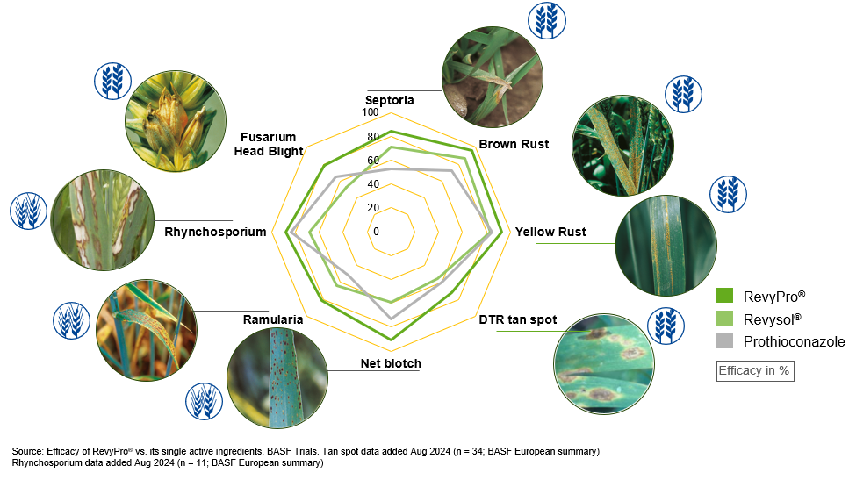

Jared Bonner, Business Development Manager, BASF said, “RevyPro’s unique formulation ensures it can be relied on to deliver broad spectrum control. It gives exceptional leaf and ear coverage, with rapid uptake getting both the Revysol and prothioconazole components into the leaf faster than other prothioconazole products. This ensures better protection from wash-off and UV degradation whilst enabling quicker activation of prothioconazole resulting in enhanced disease activity.”
RevyPro® in Wheat
RevyPro® is the partner of choice for wheat tank mixes. Combining RevyPro® with other modes of action (MoA) bolsters the performance of mixture partners when targeting Septoria and rusts, delivering a more balanced mix.
Rebecca Joynt said, “ADAS did trials comparing 1L/ha Questar (fenpicoxamid) + 1L/ha RevyPro to 1.25L/ha Univoq (fenpicoxamid+ prothioconazole). We found that the Questar + RevyPro treatment gave a reduction in Septoria and in some places a yield response associated with that, compared to the Univoq treatment.”
Jared said, “As the ADAS trials have shown, when in mixes RevyPro boosts the level of disease control and enhances the performance of the mix partner it is used with. Because of RevyPro’s efficacy growers can be flexible with dose rates, allowing the dose rate of higher resistance risk actives to be lowered whilst keeping performance levels the same or better. This delivers both resistance management and cost benefits to the grower.”
For resistance management purposes when targeting Septoria, RevyPro® should be used in a mix with another product containing a different MoA group to triazoles that control Septoria.
RevyPro® in barley
RevyPro® provides well balanced disease control covering all major barley diseases; net blotch, Rhynchosporium, rust and ramularia.
David Leahy, Business Development Manager, BASF said, “RevyPro’s flexibility means it can be used either at T1 or T2 as a standalone product, with rates in the range of 0.75 – 1.0L/ha or it can be mixed with SDHIs or strobilurins if a grower is faced with a particular disease issue.
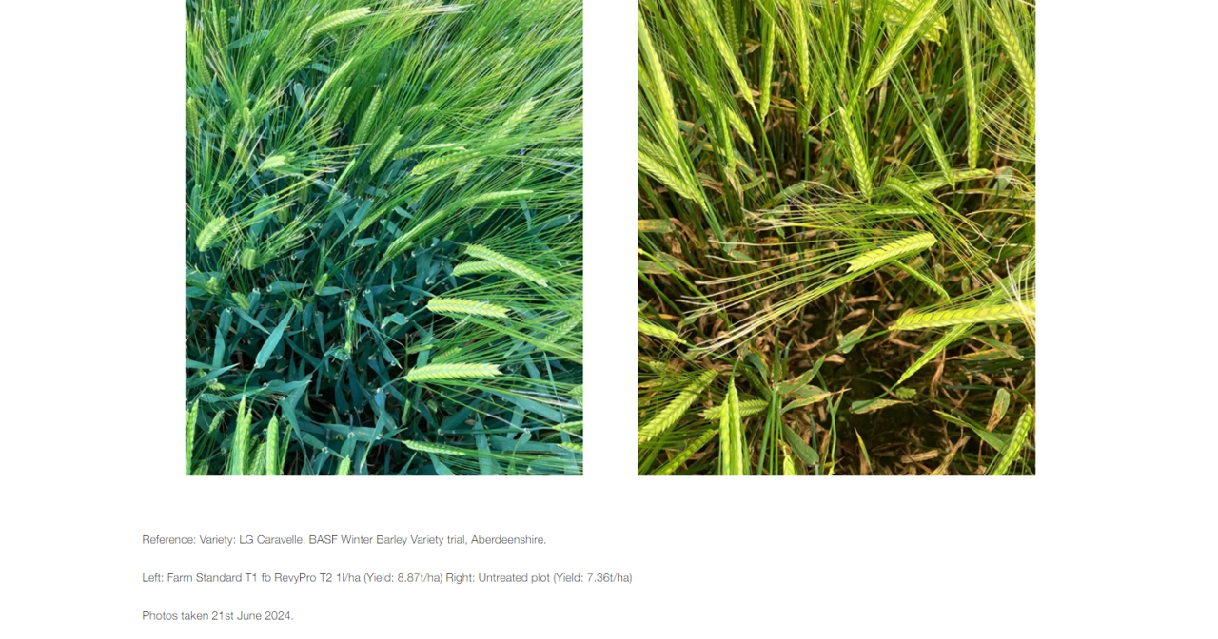
In order to maximise both winter and spring barley yields it is absolutely crucial to get the basics right. To help growers with this, BASF in collaboration with ADAS, Teagasc, SRUC, and NIAB have compiled the Barley Agronomy Guide.
To download the Barley Agronomy Guide click here: BARLEYGUIDE_2025 FINAL_digital or visit Barley Crop Management
Disclaimer
Use plant protection products safely. Always read the label and product information before use. For further product information including warning phrases and symbols refer to www.agricentre.basf.co.uk RevyPro® contains mefentrifluconazole + prothioconazole. Myresa contains Revysol®. Decoy contains prothioconazole. Questar contains fenpicoxamid. Univoq contains fenpicoxamid + prothioconazole. RevyPro®, Revysol® and Myresa ® are registered Trademarks of BASF. All other brand names used in this publication are Trademarks of other manufacturers in which propriety rights may exist. © BASF 2025. All rights reserved.

About BASF’s Agricultural Solutions division
Everything we do, we do for the love of farming. Farming is fundamental to provide enough healthy and affordable food for a rapidly growing population, while reducing environmental impacts. That’s why we are working with partners and experts to integrate sustainability criteria into all business decisions. With €944 million in 2023, we continue to invest in a strong R&D pipeline, combining innovative thinking with practical action in the field. Our solutions are purpose-designed for different crop systems. Connecting seeds and traits, crop protection products, digital tools and sustainability approaches, to help deliver the best possible outcomes for farmers, growers and our other stakeholders along the value chain. With teams in the lab, field, office and in production, we do everything in our power to build a sustainable future for agriculture. In 2023, our division generated sales of €10.1 billion. For more information, please visit www.agriculture.basf.com or our social media channels.

About BASF
At BASF, we create chemistry for a sustainable future. We combine economic success with environmental protection and social responsibility. More than 111,000 employees in the BASF Group contribute to the success of our customers in nearly all sectors and almost every country in the world. Our portfolio comprises six segments: Chemicals, Materials, Industrial Solutions, Surface Technologies, Nutrition & Care and Agricultural Solutions. BASF generated sales of €87.3 billion in 2022. BASF shares are traded on the stock exchange in Frankfurt (BAS) and as American Depositary Receipts (BASFY) in the United States. Further information at www.basf.com.

