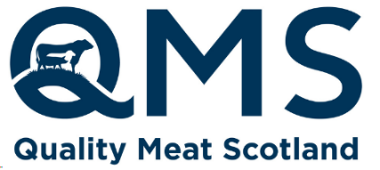

New Release
15 May 2024
For immediate use

Quality Meat Scotland starts search for new Scotch ambassadors

Quality Meat Scotland (QMS) is looking for ambassadors to support its wider reputation work to promote the benefits of Scotch Beef, Scotch Lamb and Specially Selected Pork to communities around Scotland.

Ambassadors will be involved in various activities including on-farm food and farming events, classroom sessions and cookery demonstrations. They will also provide support at industry events such as Scotsheep, and may be asked to feature in case studies as part of campaign work as part of the role.

The positions help to fulfil a key part of QMS’s strategy to connect with consumers about the benefits of including red meat as part of a healthy, balanced and sustainable diet.

“For these roles, where ambassadors will be paid for the time involved, we are looking for candidates with a genuine passion for agriculture and who enjoy working with young people,” explains Tracy Martin, Health and Education Coordinator at Quality Meat Scotland.

“We would welcome applications from people who have good communication and interpersonal skills, and are keen to be part of a team which is passionate about talking to people about the positives of Scotland’s red meat sector from farm to fork.

“It’s an opportunity to get involved in something that is really rewarding, and is crucial part of QMS’s remit to help educate people about the benefits of Scotch and Specially Selected brands. If you would like to be part of our team, we would love to hear from you.”

Daniella Forbes, who works in a similar role as a QMS cookery demonstrator, adds: “I have been delivering cookery demos and workshops in schools around the Central Belt for over six years. The QMS initiative is such a great opportunity to showcase Scottish produce and cookery skills to our young people. Not only does it make them more knowledgeable about how our world class red meat is produced, it also encourages them to taste ingredients that may be new to them, and inspires them to cook the dishes themselves.”

QMS will provide comprehensive training and resources to selected ambassadors. More details on the roles can be found by emailing info@qmscotland.co.uk. Application is straightforward; submit a CV and cover letter to tmartin@qmscotland.co.uk by 22 July.

