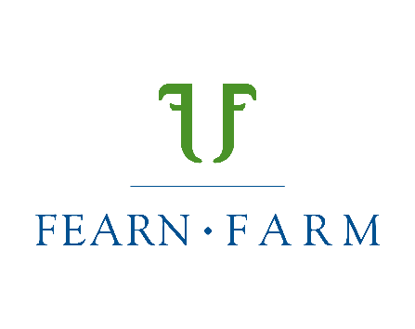

**Make no beef about it, online cattle auction finds a market**

An online cattle sale that came about as a way of marketing stock during the covid pandemic is preparing for its fourth annual event.

Farmers John and Fiona Scott came up with the way of selling their rams when coronavirus cast its shadow on traditional sales. It was so successful they used the same format to launch their ‘Northern Lights’ cattle breeding sale.

This year’s sale culminates on January 26th, with bidders from across the UK and Northern Ireland expected to travel up to the Scott family’s Fearn Farm, Ross-shire in the Highlands, to view the cattle in person.

John, who is vice president of the Beef Shorthorn Cattle Society, is quick to flag up that bidding around a traditional auction ring still has its place and strongly believes society sales play a vital role.

“However, for many reasons this system suits us,” explains John. “Given our location - 40 miles north of Inverness - costs are often magnified. By selling at home we have reduced our diesel, feed and labour bills.

“What we have ended up with, started out of necessity when it was the pandemic, is a kind of hybrid of online and in-person. Half of the buyers come up and see the stock and the other half trust the quality we produce and are happy to bid without viewing them in the flesh.

“It’s much less stressful for the cattle, given the long journeys involved in getting to the sale ring, and it means we can market them very much from the farm as working forage-fed animals.”

John’s long-held connections with New Zealand, having travelled over there widely including a Nuffield Scholarship and employing over 50 kiwis on a seasonal basis over recent years, brought him to using the YourBid online platform.

It has a Helmsman style format where the whole sale finishes at the same time and was developed by farmers David and George Giddings of Meadowslea Genetics who integrated an online bidding option for their stud Angus female sale in 2020 whilst New Zealand was in lockdown.

“We make a gathering of it on the farm on the final day of bidding, laying on hot food and refreshments and it’s become quite the social occasion,” explains John. “We find that our buyers have adapted to the system well, some people bid early and others leave it until the last minute from their mobile phone wherever they happen to be. Others like to travel up here and see the stock and hand in bidding slips.”

Buyers need to register beforehand at [www.fearnfarm.com](http://www.fearnfarm.com) with bidding commencing on January 19th at 10am and running until the conclusion of the sale on January 26th.

In total, 66 lots are included including Beef Shorthorn bulls, heifers and semen. The online catalogue includes pictures, performance figures and genetics.

Among the lots are Fearn Statesman, out of the same cow as last year’s top priced bull Fearn Ruairidh who made a herd record £17,500. Highlights among the heifers include lot 16, Fearn Monique S2004 whose dam and maternal grand dam classified excellent.

“All of our bulls are the real deal,” concludes John, who is the fourth generation to farm at Fearn Farm. “They have been semen tested and inspected and we’re delighted with the way they have turned out, perfect for both commercial and pedigree herds. Selling them this way means they can be allowed to grow naturally with the minimum of stress.”

Stock are part of Johnes level 1 and BVD accreditation schemes and have been double vaccinated for BVD, with the heifers also vaccinated for Lepto. For further information visit [www.fearnfarm.com](http://www.fearnfarm.com)

For further information contact John Scott on 07770 863506